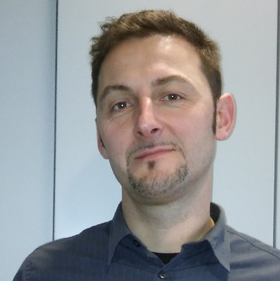
JOKIČ Željko, Project administration

Name: Željko Jokič
Name of the institution: Chamber of Commerce and
Industry of Slovenia – Metal Processing Industry
Association
Acronym: MPIA-CCIS
Position held: Senior consultant at MPIA-CCIS since
2008

Željko Jokič has been a senior consultant at the Metal Processing Industry Association since 2008 and is primarily responsible for communication with member companies and implementation of the Association’s activities. He is active in the national board for Occupational Standards and is overseeing various other expert activities within the Association, such as occupational skills development and VET, industry 4.0, and health and safety in the Slovene metal processing industry.

He has gained extensive experience in working on various European projects such as:
- KnowME – Skills and knowledge management in Metal and Electro industry,
- National project “poZDRAV – Health and safety project”.

He is currently working on the following national and international projects:
- Skills and competences in Metal and Electro industry – skillME,
- National Health and safety project “3xZDRAVo”,
- Industry4EU.

